# Classification guide for the Supported Employment Services Award

## Who can use this classification guide?

This guide will help employers to read and apply the classification levels in the Supported Employment Services Award 2020 (SES Award) that apply from 30 June 2023.

This guide is not a substitute for reading and applying the classification definitions in Schedule A of the SES Award.

|  |
| --- |
| * **IMPORTANT: The classifications in the SES Award have changed**   There are now 9 possible classifications (also called ‘levels’ or ‘grades’) for employees working under this award.  **Employers need to classify all employees (with and without disability) using the new classification structure.** The new classifications apply from employees’ first full pay period starting on or after 30 June 2023. |

## What is a classification?

Classifications describe the different types of work an employee can do under an award, including the skill and responsibility involved and the employee’s level of education, training and experience.

An employee’s classification (sometimes referred to as their ‘level’ or ‘grade’) also sets their minimum pay rate.

## How do I classify my employees?

### Step 1: Determine whether the SES Award covers your business

Consider whether the SES Award covers your business.

The SES Award covers employers who provide services to support the paid employment of people with disability. This includes people:

(a) for whom competitive employment at or above the relevant award wage is unlikely

(b) who need substantial ongoing support to obtain or retain paid employment because of their disability.

Employees engaged through labour hire who are deployed in a business that provides supported employment services may also be covered by the SES Award.

The SES Award covers employees who are in the classifications listed in Schedule A of the award.

**Step 2: Consider the job and the employee’s qualifications, training and experience**

Consider the main purpose and requirements of the role and the employee’s qualifications, training and experience.

Think about what the employee actually does (don’t just rely on their title or position description), the supervision they require (or provide) and any qualifications, training or relevant experience they have.

### Step 3: Use the classification flowchart to find the possible grade

The Classification flowchart below asks questions to help direct you towards the possible grade for your employee.

### Step 4: Confirm against the award

Read the classification definitions in [Schedule A of the SES Award](https://library.fairwork.gov.au/award/?krn=MA000103) (summarised on pages 4 and 5 of this guide), using the possible grade you identified in step 3 as a starting point.

|  |
| --- |
| **Tip: If you’re considering Grades 2-5 check the** **Reference classifications** **on page 6 of this guide.**  Reference classifications help you find the correct classification in the SES Award, by comparing the employee’s work to similar work in a relevant industry-based award. For example, if the employee is performing cleaning work, check the Cleaning Services Award to see what level best aligns with their skills and duties. If the appropriate reference classification is a Cleaning Services Employee Level 1, this indicates the employee should most likely be classified as a Grade 3 under the SES Award.  The reference classifications are not an exhaustive list. Employees can still be classified in a grade if their work doesn’t fit into any of the listed reference classifications, but they otherwise fall within the classification definition. |

When you’ve found what seems like the right classification, read and compare the classification above and the one below. This is a good way to make sure you have selected the classification that best fits your employee.

### Step 5: Review as required

Remember that you may need to review your employee’s classification if they change roles, are given more responsibility, or complete relevant training.

|  |
| --- |
| Informing your supported employees of their classification The SES Award requires employers to take all reasonable steps to provide supported employees with the information they need to exercise their employment rights. From 30 June 2023 it also allows supported employees to request their classification be reviewed.  Use our free [Template for writing an Easy Read letter](https://www.fairwork.gov.au/ses-award-template) available at fairwork.gov.au/ses-award-template to tell your employee their classification and to explain supported wage assessments, and pay. |

## Classification flowchart

This classification flowchart is for the SES Award.

**It will help you identify a possible grade for your employee, to use as a starting point for determining an employee’s classification under the award.**

It is a guide only – using this flowchart is not a substitute for reading and applying the classification definitions in Schedule A of the [SES Award](https://library.fairwork.gov.au/award/?krn=MA000103). You can [find a copy of the Award](https://library.fairwork.gov.au/award/?krn=MA000103) at library.fairwork.gov.au/award/?krn=MA000103

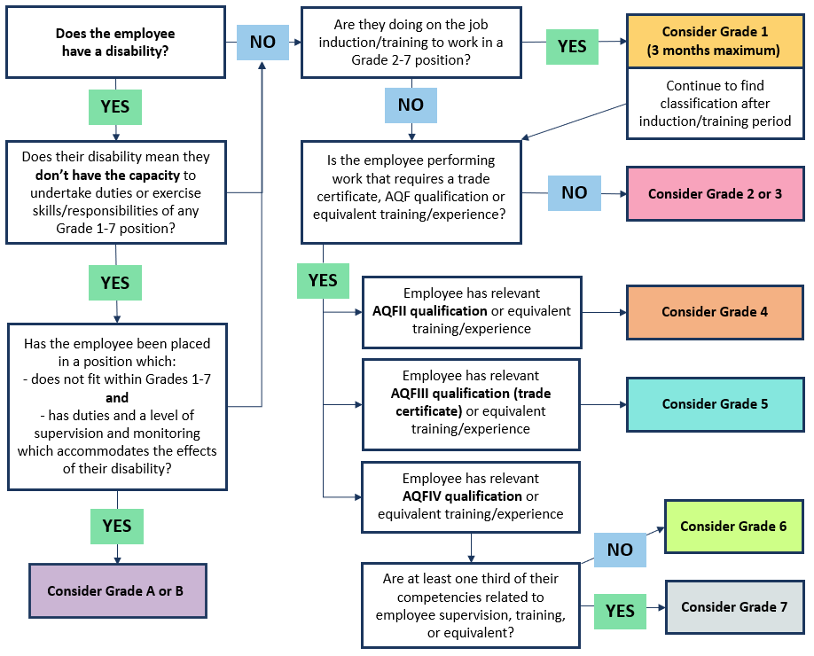

## Classification summary for the Supported Employment Services Award

|  |  |
| --- | --- |
| **Grade A** | Employees at this grade perform a simple task(s) of up to 3 sequential steps or sub-tasks which can include:   * the use of jigs or basic equipment or tools * work under direct supervision and constant monitoring. |
| **Grade B** | Employees at this grade perform a simple task(s) with 4 or more sequential steps or sub-tasks which can include:   * the use of mechanical or electric equipment or tools * work under direct supervision and regular monitoring. |
| **Grade 1** | Employees at this grade are undertaking on the job induction and/or training to perform work in Grade 2 or above.  Employees can be classified at this grade for a maximum of 3 months. |
| **Grade 2** | Employees at this grade:   * perform basic task(s) in accordance with defined procedures * understand and undertake basic quality control/assurance procedures * can recognise basic quality deviations/faults * work under direct supervision * may perform work covered by the **Grade 2 reference classifications**. |
| **Grade 3** | Employees at this grade:   * perform work above and beyond the skill of a Grade 2 employee and to their level of training * perform a more complex task(s) than at Grade 2 in accordance with defined procedures * work under routine supervision * may perform work covered by the **Grade 3 reference classifications**. |
| **Grade 4** | Employees at this grade **either**:   * perform work above and beyond the skill of an employee at Grade 3 and below and to their level of training * hold a qualification at or equivalent to AQFII or above or an equivalent level of training and experience * work independently from complex instructions and procedures * assist in the provision of on-the-job training * co-ordinate work in a team environment or work individually under general supervision and * are responsible for ensuring quality of their own work   **or**   * perform work covered by the **Grade 4 reference classifications**. |
| **Grade 5** | Employees at this grade **either**:   * perform work above and beyond the skill and level of training of an employee at Grade 4 and below and to their level of training * hold a trade certificate or an equivalent qualification or have an equivalent level of training and experience * perform work primarily involving the skills of their trade and * may also perform tasks incidental to that work   **or**   * perform work covered by the **Grade 5 reference classifications**. |
| **Grade 6** | Employees at this grade:   * perform work above and beyond the skill of an employee at Grade 5 and below and to their level of training * hold a qualification at or equivalent to AQFIV or above or have an equivalent level of training and experience * will do one or more of the following:   + assess the ability of an employee with disability to carry out specific work tasks   + design, develop and provide individual instruction or training for an employee with a disability   + undertake specialist functions in the workplace such as procurement or marketing   + supervise employees in a section of the workplace. |
| **Grade 7** | Employees at this grade:   * perform work above and beyond the skill of an employee at Grade 6 and below and to their level of training * hold a qualification at or equivalent to AQFIV or above, of which one third of the competencies are related to the supervision or training of employees – or have an equivalent level of training and experience * will co-ordinate and supervise employees **and/or** * will have responsibility for the content and delivery of training, **and** * can operate all equipment or tools to be used by employees that they are supervising or training. |

**The SES Award provides** **Reference classifications** **for Grades 2-5. These are listed below.**

Reference classifications help you find the correct classification, by comparing the employee’s work to similar work in a relevant industry-based award. For example, if the employee is performing cleaning work, check the Cleaning Services Award to see what level best aligns with their skills and duties. If the appropriate reference classification is a Cleaning Services Employee Level 1, this indicates the employee is most likely classified as a Grade 3 under the SES Award.

Reference classifications provide a guide or indication – they are not an exhaustive list. Employees can still be classified in a trade if their work doesn’t fit into any of the listed reference classifications.

## Reference classifications for the Supported Employment Services Award

|  |  |  |
| --- | --- | --- |
| **Grade 2** | Food, Beverage and Tobacco Manufacturing Award | Level 2 |
| Gardening and Landscaping Services Award | Level 1 |
| Horticulture Award | Level 2 |
| Hospitality Industry (General) Award | Level 1 |
| Manufacturing and Associated Industries and Occupations Award | Level C13 |
| Textile, Clothing, Footwear and Associated Industries Award | Skill level 1 |
| Timber Industry Award – General or Furniture Streams | Level 2 |
| **Grade 3** | Cleaning Services Award – Cleaning Services Employee | Level 1 |
| Dry Cleaning and Laundry Industry Award – Laundry employee | Level 2 |
| Food, Beverage and Tobacco Manufacturing Award | Level 3 |
| Gardening and Landscaping Services Award | Level 2 |
| Horticulture Award | Level 3 |
| Hospitality Industry (General) Award | Level 2 |
| Manufacturing and Associated Industries and Occupations Award | Level C12 |
| Storage Services and Wholesale Award – Store worker | Grade 1 |
| Textile, Clothing, Footwear and Associated Industries Award | Skill level 2 |
| Timber Industry Award - General or Furniture Streams | Level 3 |
| Waste Management Award | Level 2 |
| **Grade 4** | Cleaning Services Award – Cleaning Services Employee | Level 2 |
| Dry Cleaning and Laundry Industry Award – Laundry employee | Level 3 |
| Food, Beverage and Tobacco Manufacturing Award | Level 4 |
| Gardening and Landscaping Services Award | Level 3 |
| Horticulture Award | Level 4 |
| Hospitality Industry (General) Award | Level 3 |
| Manufacturing and Associated Industries and Occupations Award | Level C11 |
| Storage Services and Wholesale Award – Store worker | Grade 2 |
| Textile, Clothing, Footwear and Associated Industries Award | Skill level 3 |
| Timber Industry Award - General or Furniture Streams | Level 4 |
| Waste Management Award | Level 3 |
| **Grade 5** | Cleaning Services Award – Cleaning Services Employee | Level 3 |
| Dry Cleaning and Laundry Industry Award – Laundry employee | Level 4 |
| Food, Beverage and Tobacco Manufacturing Award | Level 5 |
| Gardening and Landscaping Services Award | Level 4 |
| Horticulture Award | Level 5 |
| Hospitality Industry (General) Award | Level 4 |
| Manufacturing and Associated Industries and Occupations Award | Level C10 |
| Storage Services and Wholesale Award – Store worker | Grade 3 and 4 |
| Textile, Clothing, Footwear and Associated Industries Award | Skill level 4 |
| Timber Industry Award - General or Furniture Streams | Level 5 |
| Waste Management Award | Level 4, 5 and 6 |