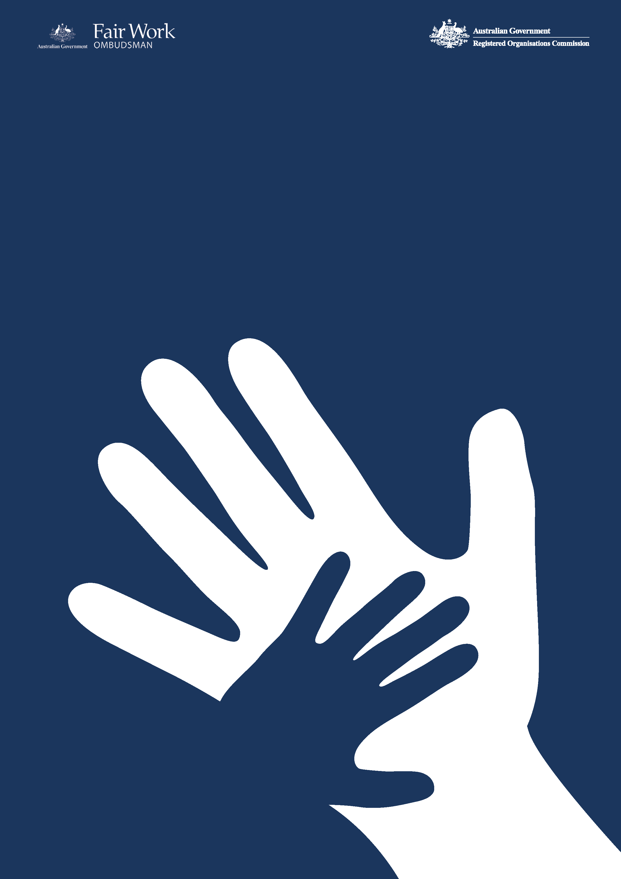­­

Commonwealth Child Safe Framework

**OFWO**

**Annual Statement of Compliance**

**2022-23** Financial Year

1. **OFWO’s commitment to child safety**

The Office of the Fair Work Ombudsman (OFWO) is committed to ensuring the safety and wellbeing of children and young people in connection with our work and with our employees. OFWO seeks to create and maintain behaviours, practices and an organisational culture that acknowledges the importance of child safety and wellbeing. OFWO is committed to:

* Implementing strategies and taking action to promote child wellbeing and prevent harm to children.
* Creating an environment where children’s safety and wellbeing is acknowledged during the course of interactions with children and young people.
* Genuine engagement with and valuing of children.
* Creating conditions that reduce the likelihood of harm to children.
* Creating conditions that increase the likelihood of identifying any harm.
* Reporting/responding to any concerns, disclosures, allegations, or suspicions of harm.
* Making sure staff and volunteers have the skills, confidence and knowledge to keep children safe.

1. **OFWO’s interaction with children as part of its operations**

The OFWO’s jurisdiction is set out in the *Fair Work Act 2009*, its main role is to promote harmonious, productive and cooperative workplace relations through advice and education; and ensure and enforce compliance with Australian workplace laws.

The majority of OFWO staff members do not interact directly with children in the performance of their duties. Although in some instances staff members may interact with children in the course of their duties - whether it be face-to-face, over the telephone, by way of electronic communication or by accessing a record pertaining to that person. These staff members may engage with children in the following instances:

* Customer services
* Compliance and enforcement activities
* Litigation proceedings
* Education activities

The OFWO administers a Community Engagement Grants Program (CEG Program) which commenced on 1 January 2017. The CEG Program involves funding to third party providers who may in turn deliver services to children. The CEG program provides funding to not-for-profit organisations to undertake a range of activities involving the provision of professional advice, information or assistance to people within the Commonwealth workplace relations system about the operation of Commonwealth workplace laws, particularly the *Fair Work Act 2009* and may include:

* Legal advice sessions
* Community education
* Telephone or face to face advisory services
* Case work services

In the latest round of grants, the OFWO awarded a total of $7.2 million to five not-for-profit organisations. The CEG Program will see grants of between $1 million and $1.8 million provided to the organisations over four years to support people including young workers understand and exercise their rights under the Commonwealth workplace relations system. Funding will be provided from 1 January 2021 to 31 December 2024. One grant has been awarded to Youth Law Australia who will provide information, advice and education about Commonwealth workplace laws to young workers in NSW, the Northern Territory and the ACT.

1. **Child safety risk assessment**

In accordance with the requirements of the Framework an annual risk assessment was undertaken by OFWO[1]. Five key risks were identified (four rated low and one rated medium) which resulted in an overarching risk rating of low for the OFWO.

1. **Compliance with the Framework**

The OFWO is compliant with the four requirements of the Framework as set out below.

***Table 1. Summary table compliance with the Framework***

|  |  |  |  |
| --- | --- | --- | --- |
| Requirement 1  Undertake risk assessments annually in relation to activities of the entity to identify the level of responsibility for and contact with children, evaluate risks to child safety and put in place appropriate strategies to manage identified risks. | Requirement 2  Establish and maintain a system of training and compliance to make staff aware of and compliant with the Framework and relevant legislation including Working with Children Checks / Working with Vulnerable People Checks and mandatory reporting requirements. | Requirement 3  Adopt and implement the National Principles for Child Safe Organisations. | Requirement 4  Publish an Annual Statement of Compliance with the Framework including an overview of the entity’s child safety risk assessment (conducted under Requirement 1). |
| Compliant | **Compliant** | **Compliant** | **Compliant** |

**4.1 Child safety initiatives undertaken for 2022-23 financial year**

The child safety initiatives set out in Table 3 below, have been undertaken within or following the end of the 2022-23 financial year.

***Table 2. Child safe initiatives undertaken within or following the end of the 2022-23 financial year***

| Initiative | Period | Description |
| --- | --- | --- |
| As committed to in the OFWO [Annual Statement of Compliance](https://www.fairwork.gov.au/sites/default/files/2021-10/commonwealth-child-safe-framework-fworoce-annual-statement-of-compliance-2020-2021.pdf) for the 2022-23 reporting period | | |
| Internal Audit of Compliance with the Child Safe Framework | December 2022 | As part of the OFWO 2022-2023 Internal Audit Plan, an internal audit was undertaken to assess whether the OFWO’s policy and reporting (Statement of Compliance) was compliant with the Commonwealth Child Safe Framework. The audit found the OFWO is compliant with the Commonwealth Child Safe Framework and has met all four requirements of the Framework and the Statement of Compliance submitted to the National Office for Child Safety and published on the OFWO website.  The internal audit recommended that the OFWO undertake a more structured system to ensure that all staff complete the mandatory Commonwealth Child Safe Framework online training module within the allowed 90 day timeframe. This has been actioned. |
| Updated Child Safety and Wellbeing Policy | 2022-23 | Updates to the internal Child Safety and Wellbeing Policy that:   * references the OFWO’s child safe governance arrangements including relevant policies and procedures (including information sharing, record keeping policies, accessibility, anti-discrimination, cultural safety, diversity and inclusion and online interaction policies). * includes Information regarding mandatory reporting obligations, Working with Children Checks (WWCC) / Working with Vulnerable People (WWVP) checks. * details how the OFWO implements the National Principles for Child Safe Organisations. |
| Online risk assessment | Conducted following the end of 2022-23 FY | Online environment has been reviewed as part of the annual risk assessment for the year ahead (2023-24 financial year) with appropriate controls in place – see section 3. |
| Child Safe Framework training module | Conducted following the end of 2022-23 | The Child Safe Framework online training module has been reviewed and updated to ensure it is contemporary and includes reference to the Child Safety and Wellbeing Policy. |
| Formalisation of compliance regime | Conducted following the end of 2022-23 FY | Following the end of the 2022-23 financial year the following activities were undertaken to monitor compliance with the Framework and will be undertaken on an annual basis:   * review of position requirements to determine which staff may require WWCCs or WWVPs - currently no staff require WWCCs or WWVPs. * confirmation that all staff who commenced with the OFWO within the financial year have completed the Child Safe Framework training module – Staff who have not completed will be reminded of their obligation to complete the training module. * Review of all reports made by staff in relation to potential child abuse or neglect to ensure appropriate action taken (including meeting reporting requirements) – two instances of potential child abuse or neglect were raised by staff during the financial year and referred to the appropriate state and territory authorities. * Review of the inclusion of child safety clauses in contracts with third party suppliers / grant recipients. * review and update of child safety related policies and procedures. |
| Other Initiatives | | |
| Mandatory training | 2022-23 | Throughout the course of the 2022-23 financial year all new staff members have been required to complete a mandatory Commonwealth Child Safe framework online training module. |
| Dedicated Child safe Intranet Page | 2022-23 | Updated dedicated Commonwealth Child Safe Framework intranet page to provide guidance to staff on the key elements of the Framework including links to Child Safety and Wellbeing Policy and useful resources and guidance materials. |

**4.2 Measures to improve compliance**

In the course of the 2023-24 financial year the OFWO’s compliance with the Framework will continue to be monitored and assessed, and subject to formal reporting for the period.

1. The risk assessment was undertaken in July 2023 following the end of the financial year in order to assist with the assessment of OFWO compliance with the Framework for the 2023-24 reporting period and ensure risks and controls were contemporary for the year ahead.