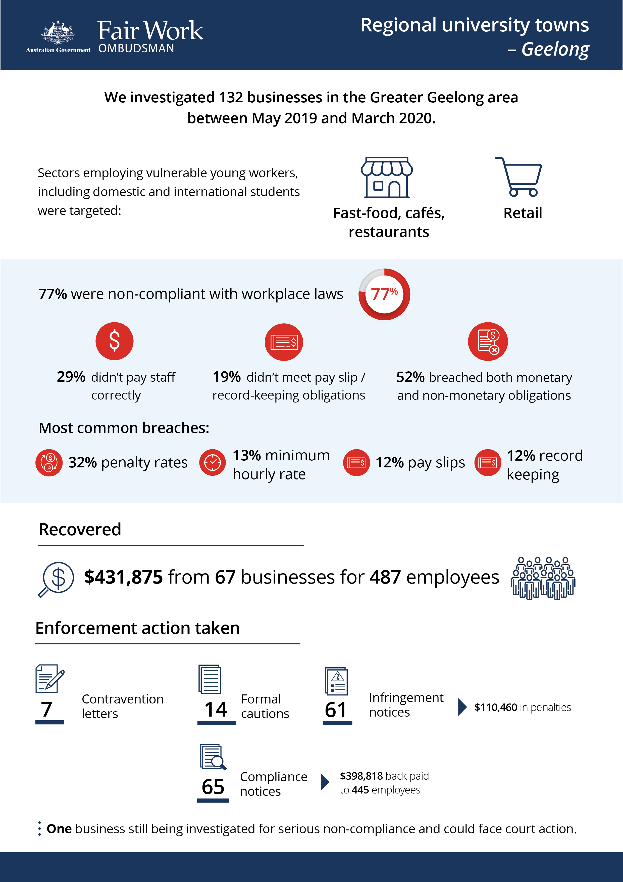-

# Regional University Towns – Geelong

## What we did and why

The Fair Work Ombudsman (FWO) conducted a rolling program of investigations in regional university towns. It focused on businesses in sectors that rely heavily on vulnerable young workers, including domestic and international students (e.g. take-away food outlets, cafes and restaurants, retail).

Our last activity looked at compliance in the university towns of Ballarat, Wollongong and Albury-Wodonga.[1]

This time we investigated 132 hospitality and retail businesses in the Greater Geelong area; between May 2019 and March 2020. Geelong has two universities, several smaller independent tertiary education facilities and is home to approximately 15,000 tertiary students.[2]

Fair Work Inspectors assessed records against the *Fair Work Act 2009* (the Act), the *Fair Work Regulations 2009* (the Regulations) and applicable modern awards (e.g. *Fast Food Industry Award 2010*, *Restaurant Industry Award 2010* and the *General Retail Industry Award 2010*) and enterprise agreements. Education resources were provided to employers to assist with compliance.

## Our findings

Unfortunately, more than three-quarters of the businesses investigated (102 businesses or 77%) had breached workplace laws. Of those:

* 30 (29%) were not paying staff correctly.
* 19 (19%) were non-compliant with pay slip and record-keeping requirements.
* 53 (52%) breached both their monetary and non-monetary obligations.[3]

The most common breaches related to:

* under / non-payment of penalty rates (33%)
* underpayment of the minimum hourly rate (13%)
* failure to comply with record-keeping requirements as per the Act and Regulations (12%).
* failure to provide pay slips as per requirements of the Act and Regulations (12%).

The reasons given for non-compliance included:

* lack of awareness of workplace relations obligations (55%)
* misinterpretation of award requirements (15%)
* business decision eg. paying flat hourly rates to save on administration costs without compensating for penalties 11%
* other reasons e.g payroll software issues / limitations (9%)
* missed the July annual wage increase (6%)
* incorrect advice from a third party e.g an accountant (4%).

## Action taken and next steps

Employers were required to remedy non-compliance and provide evidence of action taken, for example proof of payment of outstanding employee entitlements.

We recovered $431,875 from 67 businesses for 487 employees.

Fair Work Inspectors issued:

* 7 contravention letters, putting employers on notice about the consequences of continued non-compliance
* 14 formal cautions
* 65 compliance notices, with back payments of $398,818 for 445 employees
* 61 infringement notices, totalling $110,460 in penalties for pay slip and record-keeping breaches.

One business remains under investigation for serious non-compliance and may face legal proceedings.

Non-compliant employers were made aware of FWO’s free tools and resources. They were also advised that repeated breaches will see a stronger response, including possible legal action and significantly higher financial penalties.

A lack of awareness is not a valid reason for non-compliance in the workplace. The FWO expects all employers to comply with basic workplace relations obligations and to utilise our free tools and resources, including:

* PACT - calculates employee entitlements, including award pay rates, leave entitlements and termination pay.[4]
* My account - interactive service where employers receive tailored information and updates.[5]
* Online Learning Centre - award-winning videos on key subjects like hiring employees, managing performance and record-keeping and pay slip obligations.[6]
* Templates and guides - tools and resources specifically designed to assist businesses with their payslips and record keeping obligations.[7]

The FWO regards employers who don’t take advantage of these free tools and resources as negligent.

A compliance rate of 23% is clearly disappointing. We will continue our education and enforcement activities in sectors employing vulnerable workers in a sustained effort to tackle low compliance.

1. FWO report: https://www.fairwork.gov.au/ArticleDocuments/714/compliance-activities-in-regional-education-centres-report.docx.aspx
2. ABS 2016 Census: https://quickstats.censusdata.abs.gov.au/census_services/getproduct/census/2016/quickstat/LGA22750
3. Percentages have been rounded to the nearest whole number
4. <https://calculate.fairwork.gov.au/>
5. <https://www.fairwork.gov.au/my-account/registerpage.aspx>
6. <https://www.fairwork.gov.au/how-we-will-help/online-training/online-learning-centre>
7. https://www.fairwork.gov.au/how-we-will-help/templates-and-guides