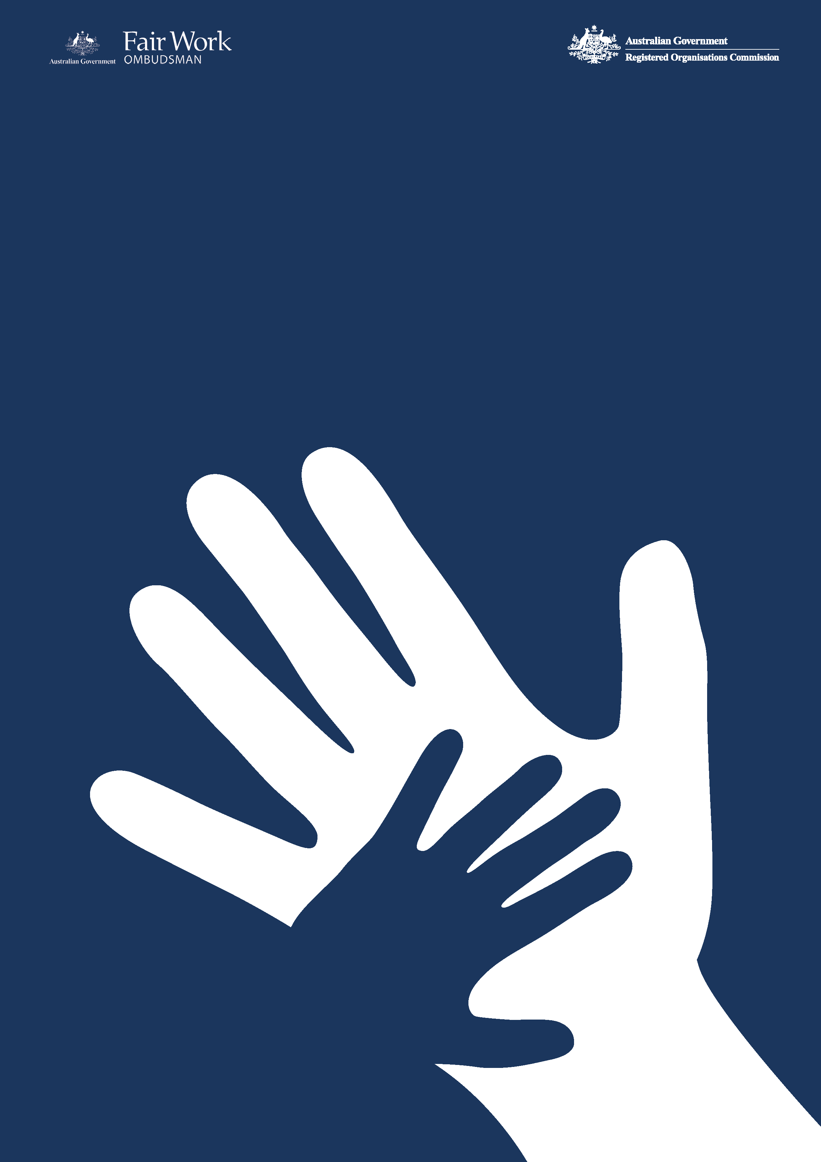­­

Commonwealth Child Safe Framework

**Fair Work Ombudsman**

**Annual Statement of Compliance**

**2023-24** Financial Year

1. **FWO’s commitment to child safety**

The Office of the Fair Work Ombudsman (FWO) is committed to ensuring the safety and wellbeing of children and young people in connection with our work and with our employees. FWO seeks to create and maintain behaviours, practices and an organisational culture that acknowledges the importance of child safety and wellbeing. FWO is committed to:

* Implementing strategies and taking action to promote child wellbeing and prevent harm to children.
* Creating an environment where children’s safety and wellbeing is acknowledged during the course of interactions with children and young people.
* Genuine engagement with and valuing of children.
* Creating conditions that reduce the likelihood of harm to children.
* Creating conditions that increase the likelihood of identifying any harm.
* Reporting/responding to any concerns, disclosures, allegations, or suspicions of harm.
* Making sure staff and volunteers have the skills, confidence and knowledge to keep children safe.

1. **FWO’s interaction with children as part of its operations**

The FWO’s jurisdiction is set out in the *Fair Work Act 2009*, its main role is to promote harmonious, productive, cooperative and compliant workplace relations in Australia through advice and education; and take appropriate enforcement action.

The majority of FWO staff members do not interact directly with children in the performance of their duties. Although in some instances staff members may interact with children in the course of their duties - whether it be face-to-face, over the telephone, by way of electronic communication or by accessing a record pertaining to that person. These staff members may engage with children in the following instances:

* Customer services
* Compliance and enforcement activities
* Litigation proceedings
* Education activities

The FWO administers a Community Engagement Grants Program (CEG Program) which commenced on 1 January 2017. The CEG Program involves funding to third party providers who may in turn deliver services to children. The CEG program provides funding to not-for-profit organisations to undertake a range of activities involving the provision of professional advice, information or assistance to people within the Commonwealth workplace relations system about the operation of Commonwealth workplace laws, particularly the *Fair Work Act 2009* and may include:

* Legal advice sessions
* Community education
* Telephone or face to face advisory services
* Case work services

The current grants involve a total of $8.1 million for five not-for-profit organisations with grantees receiving between $1.125 million and $2.025 million over the period from 1 January 2021 to 30 June 2025 to support people including young workers understand and exercise their rights under the Commonwealth workplace relations system. One grant has been awarded to Youth Law Australia who are providing information, advice and education about Commonwealth workplace laws to young workers in NSW, the Northern Territory and the ACT.

1. **Child safety risk assessment**

In accordance with the requirements of the Framework an annual risk assessment was undertaken by FWO [1]. Five key risks were identified (four rated low and one rated medium) which resulted in an overarching risk rating of low for the FWO.

1. **Compliance with the Framework**

The FWO is compliant with the four requirements of the Framework as set out below.

***Table 1. Summary table compliance with the Framework***

|  |  |  |  |
| --- | --- | --- | --- |
| Requirement 1  Undertake risk assessments annually in relation to activities of the entity to identify the level of responsibility for and contact with children, evaluate risks to child safety and put in place appropriate strategies to manage identified risks. | Requirement 2  Establish and maintain a system of training and compliance to make staff aware of and compliant with the Framework and relevant legislation including Working with Children Checks / Working with Vulnerable People Checks and mandatory reporting requirements. | Requirement 3  Adopt and implement the National Principles for Child Safe Organisations. | Requirement 4  Publish an Annual Statement of Compliance with the Framework including an overview of the entity’s child safety risk assessment (conducted under Requirement 1). |
| Compliant | **Compliant** | **Compliant** | **Compliant** |

**4.1 Child safety initiatives undertaken for 2023-24 financial year**

The child safety initiatives set out in Table 3 below, have been undertaken within or following the end of the 2023-24 financial year.

***Table 2. Child safe initiatives undertaken within or following the end of the 2023-24 financial year***

| Initiative | Period | Description |
| --- | --- | --- |
| As committed to in the FWO [Annual Statement of Compliance](https://www.fairwork.gov.au/sites/default/files/2021-10/commonwealth-child-safe-framework-fworoce-annual-statement-of-compliance-2020-2021.pdf) for the 2023-24 reporting period | | |
| Updated Child Safety and Wellbeing Policy | 2023-24 | The internal Child Safety and Wellbeing Policy was reviewed, and no substantive updates were identified, the Policy remains fit for purpose. |
| Annual risk assessment | Conducted following the end of 2023-24 FY | Online environment has been reviewed as part of the annual risk assessment for the year ahead (2024-25 financial year) with appropriate controls in place – see section 3. |
| Child Safe Framework training module | Conducted during 2023-24 | The Child Safe Framework online training module has been reviewed and updated to ensure it is contemporary and consistent with refresher training modules across all FWO online learning. |
| Formalisation of compliance regime | Conducted following the end of 2023-24 FY | Following the end of the 2023-24 financial year the following activities were undertaken to monitor compliance with the Framework and will be undertaken on an annual basis:   * FWO business areas review position requirements prior to advertising job vacancies to determine FWO positions that may require WWCCs or WWVPs - currently no positions require WWCCs or WWVPs. * Confirmation that all staff who commenced with the FWO within the financial year have completed the Child Safe Framework training module – staff who have not completed the training will be reminded of their obligation for completion monthly. * Confirmation that all staff completed the Child Safe Framework mandatory refresher training module. This is required to be undertaken as part of the FWO corporate mandatory refresher training that occurs every two years (based on the employment commencement date) – staff who have not completed the training will be reminded of their obligations for completion monthly. * Review of all reports made by staff in relation to potential child abuse or neglect to ensure appropriate action taken (including meeting reporting requirements) – nil instances of potential child abuse or neglect were raised by staff during the financial year. * Review of the inclusion of child safety clauses in contracts with third party suppliers / grant recipients. * Review and update of child safety related policies and procedures. |
| Mandatory training for all staff | 2023-24 | * During the period the mandatory refresher training module for all staff was reviewed so that it aligns with other corporate compliance refresher training modules available to staff. |

**4.2 Measures to improve compliance**

In the course of the 2024-25 financial year the FWO’s compliance with the Framework will continue to be monitored and assessed, and subject to formal reporting for the period.

1. The risk assessment was reviewed in September 2024 following the end of the financial year in order to assist with the assessment of FWO compliance with the Framework for the 2024-25 reporting period and ensure risks and controls were contemporary for the year ahead.