SA Specialised food retailing audit program

Report – January 2014

A report by the Fair Work Ombudsman under the

Fair Work Act 2009. Date of Publication – January 2014

©Commonwealth of Australia, 2014

Contents

Summary 4

Purpose of the audit program 4

Our industry partners 4

Why did we conduct the audit program? 4

What did we do? 4

What did we find? 5

Other findings 6

Concluding remarks 7

About the Fair Work Ombudsman 7

Campaign snapshot

More than

190

assessments were conducted.

Total of

57%

compliance rate.

Over

$150k

was recovered on behalf of 285 employees.

# Summary

This report details the method and findings of the SA Specialised food retailing audit program (the program) conducted by the Fair Work Ombudsman (FWO).

The aim of the program was to promote and assess compliance with the *Fair Work Act 2009* (the Act), the *Fair Work Regulations 2009* (the Regulations), the *General Retail Award 2010, the Meat Industry Award 2010* and the *Food, Beverage and Tobacco Manufacturing Award 2010*.

During the program we assessed the records of 193 employers to ensure their compliance with the following requirements:

* hourly rates of pay
* penalty rates and allowances
* record - keeping and pay slip obligations.

Of the 192 assessments completed we found 57% of employers were compliant with their obligations.

We recovered a total of $151 789 for 285 employees.

# Purpose of the audit program

The aim of the program was to promote compliance among specialised food retailers in South Australia (SA) and to ensure that employers selected for assessment were meeting their obligations.

The specific objectives were to:

* assess compliance with correct wage rates
* assess compliance with correct record -keeping and pay slip practices
* work with employers to rectify any contraventions identified
* provide employers with information about our tools and resources, particularly those available on our website.

# 

# Our industry partners

We contacted key industry stakeholders, including:

* Business SA
* Australasian Meat Industry Employees’ Union
* United Voice (SA Branch).

We invited these stakeholders to provide feedback on the campaign and to assist in promoting it through their networks.

# Why did we conduct the audit program?

FWO did an analysis of complaints received in SA during 2010/11. This analysis showed that 47% of complaints received from employees in specialised food retailing had contraventions relating to underpayments.

This sector includes meat retailing, retail bakery product manufacturing, retail fresh poultry and retail fruit and vegetables.

# What did we do?

The program started with a media release which included an invitation to employers to attend an information session. We held five sessions both in metropolitan and regional locations during July 2012.

We then wrote to a sample number of businesses further promoting the information sessions and advising them of their selection for assessment. We explained that we would be reviewing their time and wage records for a two-week sample period and what they were required to do to facilitate the assessment.

After we had completed the information sessions, we commenced the assessment phase of the program. We visited the selected businesses and reviewed their records against the requirements of:

* the Act
* the Regulations
* the *General Retail Award 2010*
* the *Meat Industry Award 2010*
* the *Food, Beverage and Tobacco Manufacturing Award 2010*.

Where we found an employer to be compliant we confirmed our findings to them in writing.

Where we identified potential contraventions we conducted further investigation. Once we had confirmed the contraventions, we explained our findings to the employer and discussed what they were required to do to rectify the contraventions identified.

We also demonstrated our online tools and resources which had been shown during the information sessions to ensure employers were both aware of them and able to effectively use them.

# 

# What did we find?

We analysed the results of the campaign in December 2013. Of the 192 audits completed we found:

* 109 (57%) businesses were compliant
* 83 (43%) businesses were in contravention.

We had recovered $151 789 for 285 employees.

One audit remains ongoing.

As shown in Chart 1, of the 83 businesses found in contravention:

* 57 (69%) had monetary contraventions
* 21 (25%) had technical contraventions relating to payslips and record keeping
* 5 (6%) had both monetary and technical contraventions.

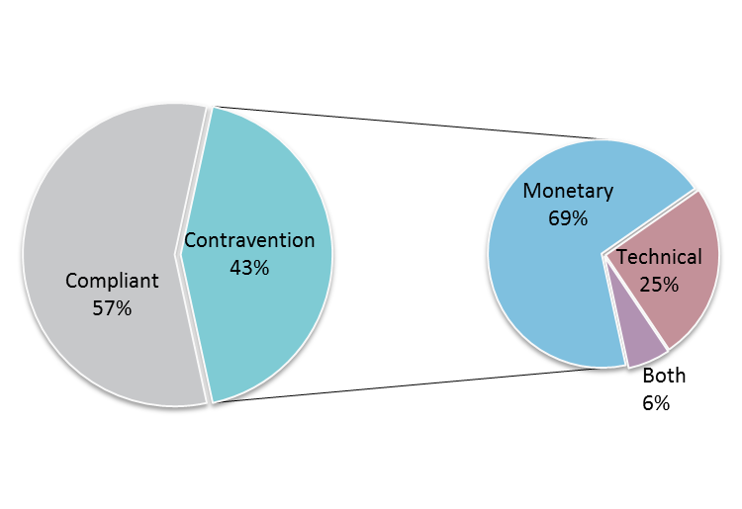

**Chart 1- Audit results:**

The 83 businesses in contravention had a total of 90 separate contraventions.

Chart 2 shows that wages and conditions accounted for more than two-thirds of all contraventions with 69%.

**Chart 2 – Types of contraventions**

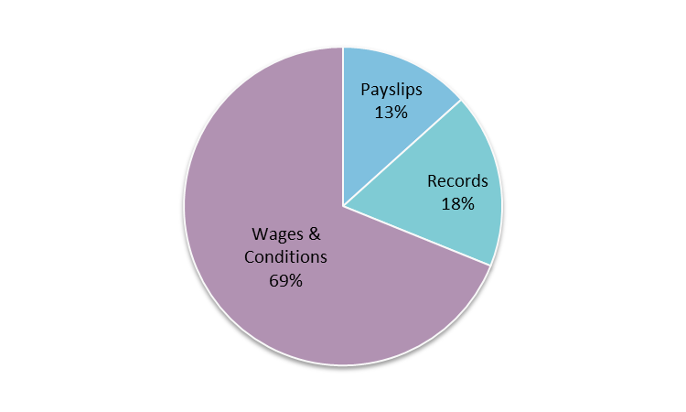

We recovered a total of $151 789 from 62 businesses on behalf of 285 employees. The amounts recovered from individual businesses ranged from less than $20 to more than $10 000, as seen in Chart 3.

**Chart 3 – Amounts recovered**

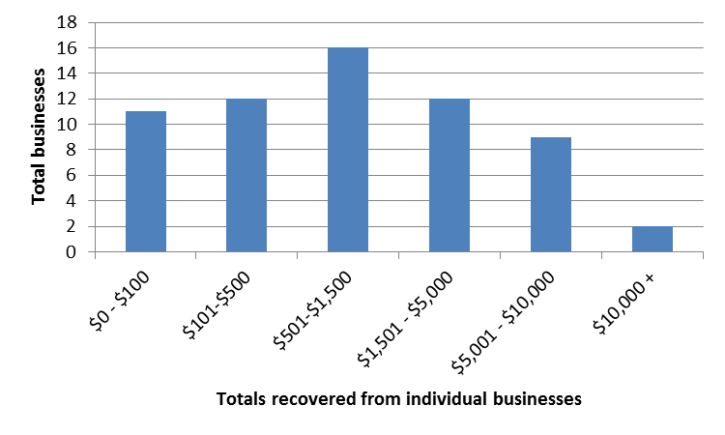

Chart 4 shows the compliance rate by regions. The highest compliance rates were found in the Yorke Peninsula and Mid-North with 77%, and the Fleurieu Peninsula and Kangaroo Island with 67%.

**Chart 4 – Compliance rates per region**

|  |  |  |  |  |
| --- | --- | --- | --- | --- |
| **Region (total audits)** | **Compliant** | **Contravention Type** | | |
| **Technical** | **Monetary** | **both** |
| Yorke and Mid North (13) | 77% | 15% | 8% | 0% |
| Fleurieu and Kangaroo Island (9) | 67% | 11% | 22% | 0% |
| Adelaide and suburbs (136) | 58% | 9% | 29% | 4% |
| Limestone Coast (4) | 50% | 0% | 50% | 0% |
| Adelaide Hills (18) | 44% | 6% | 50% | 0% |
| Eyre and Western (8) | 38% | 24% | 38% | 0% |
| Murray and Mallee (3) | 34% | 33% | 33% | 0% |
| Far North SA (1)* | 0% | 100% | 0% | 0% |

***\**** *although Far North SA appearing to have a 100% contravention rate, it should be noted that only 1 business was audited.*

# Other findings

Some significant findings reported by the Fair Work Inspectors included:

* failure to include annual wage increases
* paying ‘going rates’ or ‘industry rates’ which were below the rate set by the applicable award
* paying ‘flat’ rates across all hours worked, without any penalty rates being applied
* some employers being unfamiliar with the modern award covering their employees.

# Concluding remarks

The program showed that there was a lack of awareness about applicable awards and correct rates of pay in the industry. This was evidenced by the results showing over 40% of employers in contravention and almost 70% of contraventions related to underpayments.

However we were encouraged that employers were receptive to our advice about their obligations and in all cases voluntarily rectified the contraventions we identified.

The program provided us with an opportunity to introduce employers to our suite of online tools and resources. We hope that these resources together with the advice received from Fair Work Inspectors will improve the industry’s compliance in the future.

# About the Fair Work Ombudsman

The Fair Work Ombudsman is an independent agency created by the *Fair Work Act 2009* on 1 July 2009.

Our vision is fair Australian workplaces, and our mission is to work with Australians to educate, promote fairness and ensure justice in the workplace.

Our education and compliance campaigns target specific industries to assist them achieve compliance with national workplace laws. Our focus is usually industries which need assistance with compliance and employ vulnerable workers.

We like to work with relevant industry associations and unions to deliver our campaigns. We rely upon their ‘real world’ knowledge and communication channels to design and deliver our education activities and products.

This report covers the background, method and findings of the SA Specialised food retailing audit program.

For further information and media enquiries please contact: [media@fwo.gov.au](mailto:media@fwo.gov.au)

If you would like further information about the Fair Work Ombudsman’s targeted campaigns please contact Steve Ronson, Executive Director - Dispute Resolution and Compliance ([steven.ronson@fwo.gov.au](mailto:steven.ronson@fwo.gov.au)).

Commonwealth of Australia 2014

This work is copyright. You may download, display, print and reproduce this material in unaltered form only (retaining this notice) for your personal, non-commercial use or use within your organisation.

Apart from any use as permitted under the Copyright Act 1968, all other rights are reserved.

Requests and enquiries concerning reproduction and rights should be emailed to communications@fwo.gov.au

Copyright Act 1968 (ComLaw website)