TAS Queenstown compliance campaign 2013

Final report – April 2014

A report by the Fair Work Ombudsman under the

Fair Work Act 2009. Date of Publication – April 2014

©Commonwealth of Australia, 2014

Summary 4

Purpose of the campaign 4

Our industry partners 4

Why did we conduct the campaign? 4

What did we do? 5

What did we find? 5

Other findings 6

Concluding remarks 7

About the Fair Work Ombudsman 7

Campaign snapshot

Total of

55

businesses visited

We found

93%

of employers were paying their employees correctly

We found

60%

of employers were compliant with pay slip and record–keeping requirements

Over

$20k

was recovered on behalf of seven employees who were underpaid

TAS Queenstown compliance campaign 2013

# Summary

The Fair Work Ombudsman (FWO) commenced the Queenstown compliance campaign (the campaign) in June 2013.

The campaign aimed to promote and assess compliance with Australia’s workplace laws, particularly in relation to record-keeping and pay slip requirements.

Fair Work Inspectors visited 55 businesses in the Queenstown area of Tasmania. We spoke to employers about their obligations and provided them with tools and resources to assist them with compliance.

We also assessed a sample of their time and wage records to check pay slip and record-keeping practices and to ensure that employees were being paid correctly.

In assessing time and wage records we found:

* 51 (93%) businesses were paying their employees correctly
* 33 (60%) businesses were compliant with record-keeping and pay slip requirements.

During the campaign we recovered a total $20 816 on behalf of seven employees who were underpaid.

For further information on our findings, please refer to the body of this report.

# Purpose of the campaign

The specific objectives of the campaign were to:

* engage with local stakeholders to promote compliance
* assess businesses’ compliance with Commonwealth workplace laws, particularly in relation to record-keeping and pay slip requirements
* promote the role of the FWO and the resources we offer to assist businesses, particularly our online tools and resources
* assist employers to rectify non-compliance.

# Our industry partners

We wrote to the following stakeholders to inform them of the campaign:

* Members of Parliament of both the State and Commonwealth
* West Coast Council
* Tasmanian Hotels Association
* Workplace Standards Tasmania
* Tasmanian Chamber of Commerce and Industry
* Unions Tasmania
* Tasmanian Small Business Council

We invited these stakeholders to provide feedback on the campaign and to assist us in promoting it amongst their networks.

# Why did we conduct the campaign?

Previously we had engaged with employers in the Queenstown region through the Fair Work Info line, but had not conducted field visits to businesses in the region for some time.

Conducting ‘face to face’ visits to businesses allows Fair Work Inspectors to engage directly with employers and assist them to better understand and comply with their obligations.

We had received information suggesting the possibility that some employers in the Queenstown area had been paying employees ‘cash in hand’.

Detailed pay slips help employees to both understand and check their entitlements. We initiated the campaign to promote employer obligations with record keeping and pay slip requirements.

# What did we do?

We visited 55 businesses in Queenstown and surrounding towns including Zeehan, Strahan, Tullah, and Rosebery.

We assessed the businesses’ time and wage records to ensure compliance with the requirements of the *Fair Work Act 2009* (the Act) and the *Fair Work Regulations 2009* (the Regulations) and the applicable award.

Once the assessments were completed we discussed our findings with the employer.

* Where records were unavailable at the time of our visit we asked employers to forward their records to our office for assessment.
* Where we identified pay slip errors we required employers to complete a written undertaking to issue compliant payslips in future.
* Where we identified underpayments, we requested that they rectify the underpayment the underpayments and provide us with proof of having paid the affected employees.

Fair Work Inspectors also provided employers with advice and resources to help them understand and comply with their obligations. Where possible, we demonstrated our online tools and resources, such as [Pay Check Plus](http://www.fairwork.gov.au/pay/paycheckplus/pages/default%20).

Where we were unable to access the internet, we provided employers with copies of our [Pay Slip Template and Record-Keeping Fact Sheets](http://www.fairwork.gov.au/Resources/templates/Pages/pay-slips-and-record-keeping)

# What did we find?

Of the 55 businesses we assessed we found:

* 30(55%) employers to be compliant with all requirements
* 25 (45%) employers had at least one error, of which:
  + 21 (38%) had errors relating to pay slips
  + 3 (5%) were paying incorrect rates of pay
  + 1 (2%) concerned both wages and pay slip errors

**Table 1: Audit results**

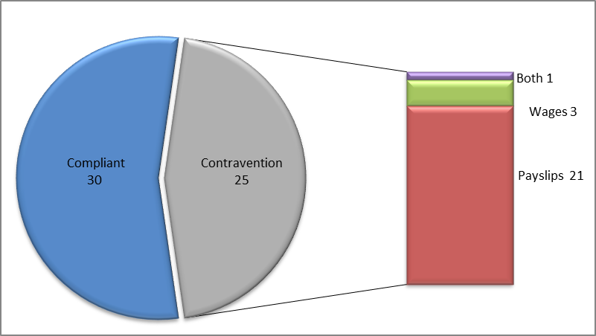This means that of the 55 businesses we visited:

* 51 (93%) were paying their employees correctly
* 33 (60%) were compliant with record-keeping and pay slip requirements.

We recovered $20 816 on behalf of seven employees.

# Other findings

Fair Work Inspectors found that most of the employers with pay slip errors were unaware of the content required and were therefore issuing pay slips without all the necessary information.

Other employers had failed to issue pay slips to their employees within one day of payment.

**Case study** – **Issuing complete pay slips**

We visited a business owned by Cantata*. When we reviewed her records we recognised that the pay slips she was issuing were lacking important information.

Cantata was under the impression that pay slips were only required to include the name of the employee and the amount paid to them. We explained to Cantata the details required to be included in pay slips and the reasons why these are important for both employers and employees. We also provided her with fact sheets, best practice pay slip templates and showed her our online tools and resources available at [www.fairwork.gov.au](http://www.fairwork.gov.au/).

When we were confident that Cantata understood these obligations we asked her to commit in writing to issuing compliant pay slips in future. She was happy to do so and at the conclusion of our visit she expressed appreciation for the time we spent helping her to understand what she needs to do to.

*a pseudonym

Four employers had errors regarding rates of pay. Two of the four had paid some rates below the minimum entitlement, but had also paid other rates above it.

In these two cases the rates that were paid above minimum entitlements offset any financial disadvantage the employees might otherwise have suffered from being underpaid other rates.

These two cases gave us an opportunity to educate the employers concerned about the minimum entitlements prescribed by the applicable award.

**Case study – Use our online tools to check pay rates**

Paul*, a local business owner, heard through the local media that FWO was visiting the area. He prepared his time and wage records in advance of our visit as he was keen to ensure that he was paying his casual staff correctly.

When we visited Paul’s premises and reviewed the rates of pay his staff were being paid, we identified an underpayment of six cents per hour for work performed Monday to Friday.

Paul was surprised with our findings and asked us to discuss this with his accounts officer.

We further explained our findings to both Paul and his accounts officer. We also showed them how we had calculated the required rate of pay by using our Pay Check Plus online tool.

On further inspection of Paul’s records we identified that the hourly rate he was paying his staff for work performed on Saturdays was above the minimum entitlement he was required to pay them. Overall, as the overpayment of minimum rates for Saturday work was worth more than the underpayment of minimum rates for Monday to Friday work, there was no financial disadvantage to his employees.

On this basis, Paul was not required to make any back pay.

He was disappointed that he had made the inadvertent error of underpaying an hourly rate and advised us that he would correct the Monday to Friday rate, but would continue to pay his current Saturday rate above the minimum entitlement.

*a pseudonym

In speaking with both employers and employees during the campaign, we found no evidence that employees working in the businesses we visited were being paid ‘cash in hand’.

Fair Work Inspectors were pleased to note that several employers were grateful for the time spent working with them to ensure they understood their obligations.

# Concluding remarks

Due to our activities in the campaign the employers we visited have a greater understanding of both their obligations and the role of the FWO in assisting them to meet their obligations.

Through our interaction with employers it was apparent that most errors resulted from a lack of awareness about the required content for pay slips. All errors identified, both for pay slips and underpayments, were voluntarily rectified.

We are hopeful that the positive engagement between the FWO, employers and local stakeholders of the Queenstown region helped both the small businesses and their staff.

# About the Fair Work Ombudsman

The Fair Work Ombudsman is an independent agency created by the *Fair Work Act 2009* on 1 July 2009.

Our vision is fair Australian workplaces and our mission is to work with Australians to educate, promote fairness and ensure justice in the workplace.

Our education and compliance campaigns target specific industries to assist them achieve compliance with national workplace laws. Our focus is usually industries that need assistance with compliance and employ vulnerable workers.

We like to work with relevant industry associations and unions to deliver our campaigns. We rely upon their ‘real world’ knowledge and communication channels to design and deliver our education activities and products.

This report covers the background, method and findings of the TAS Queenstown compliance campaign 2013.

For further information and media enquiries please contact [media@fwo.gov.au](mailto:media@fwo.gov.au).

If you would like further information about the Fair Work Ombudsman’s campaigns please contact Lynda McAlary-Smith, Executive Director – Proactive Compliance and Education Branch (lynda.mcalary-smith@fwo.gov.au).

Commonwealth of Australia 2014

This work is copyright. You may download, display, print and reproduce this material in unaltered form only (retaining this notice) for your personal, non-commercial use or use within your organisation.

Apart from any use as permitted under the Copyright Act 1968, all other rights are reserved.

Requests and enquiries concerning reproduction and rights should be emailed to [communications@fwo.gov.au](mailto:communications@fwo.gov.au)

[Copyright Act 1968](http://www.comlaw.gov.au/comlaw/Legislation/ActCompilation1.nsf/0/2E3EEB3B6191AB60CA2574FF0081BA02?OpenDocument) (ComLaw website) External link icon